**Assignment 1: Polymorphism**

The goal of this lab is to review the concepts of Inheritance and Polymorphism. In this lab, you will practice:

* Creating a new class and adding it to an existing class hierarchy.
* Using the updated class hierarchy in a polymorphic application.

(Payroll System Modification): Modify the payroll system of the figures shown below to include an additional Employee subclass PieceWorker that represents an employee whose pay is based on the number of pieces of merchandise produced. Class PieceWorker should contain private instance variables wage (to store the employee’s wage per piece, a double precision floating point number) and pieces (to store the number of pieces produced). Provide a concrete implementation of method earnings in class PieceWorker that calculates the employee’s earnings by multiplying the number of pieces produced by the wage per piece. Modify the PayrollSystemTest class to create an array of Employee variables to store references to objects of each concrete class. You will find seven (7) files that have been attached for your convenience:

1. PieceWorker (The class you have to spend most of the time working on)
2. PayrollSystemTest (Need to modify only one line of code to create a new instance of PieceWorker)
3. Employee (base class), SalariedEmployee (subclass), HourlyEmployee (subclass), ComissionEmployee (subclass), BasePlusComissionEmployee (subclass).

Here’s a sample output of the code running:

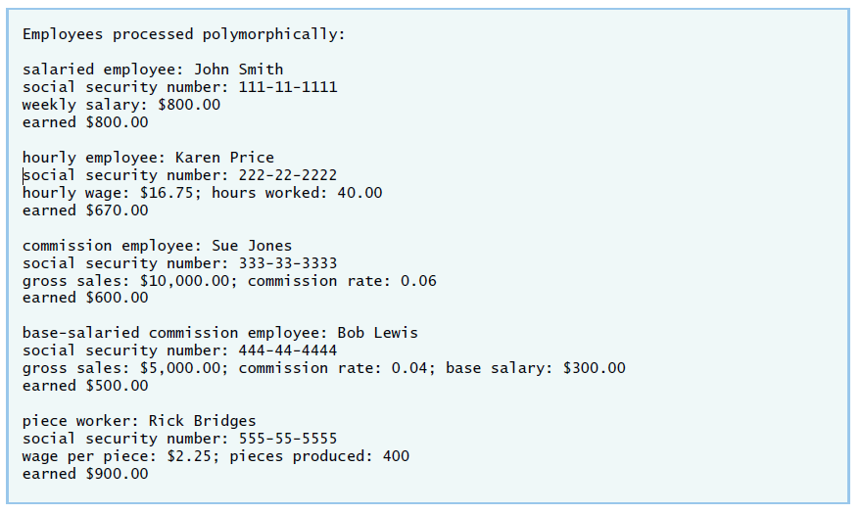

Things to keep in mind when modifying your PieceWorker class:

* The PieceWorker constructor should call the superclass Employee constructor to initialize the employee’s name.
* The number of pieces produced should be greater than or equal to 0. Place this logic in the set method for the pieces variable.
* The wage should be greater than or equal to 0. Place this logic in the set method for the wage variable.
* The main method must explicitly create a new PieceWorker object and assign it to an element of the employees array.

**Deliverables: Submit all your classes in a .jar project (not only the ones you modified).**

